InGARSS 2024
2024 IEEE India Geoscience and Remote Sensing Symposium, NIO, Goa
Hosted by IEEE GRSS Bombay Section

- Home (Front/First Webpage content)
Welcome to InGARSS 2024
Welcome to InGARSS 2024, the premier conference for advancing the field of geoscience and remote sensing! This year, we gather to exchange cutting-edge research, innovative technologies, and transformative ideas that push the boundaries of Earth observation. Join us as we explore new frontiers, collaborate with experts from around the globe, and chart a course towards a more sustainable and resilient future.
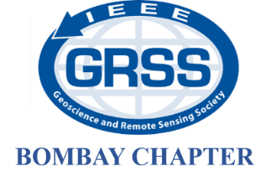
Host Chapter

Local Host Institute
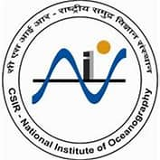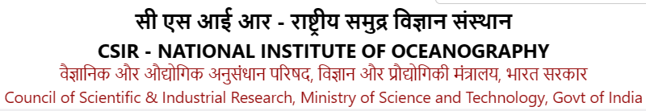

Collaborating Chapters

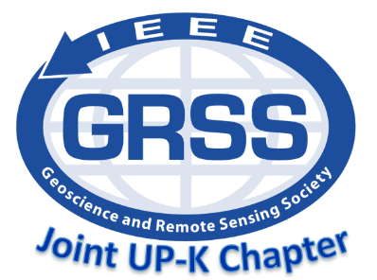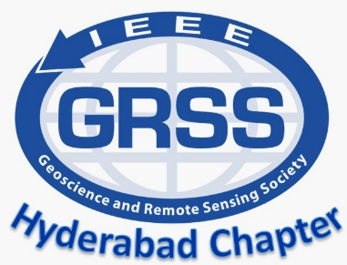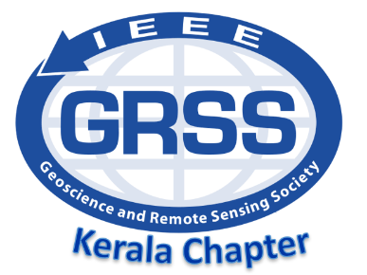

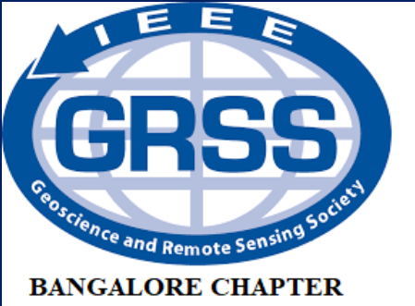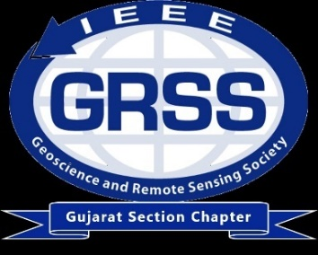
GRSS Delhi Chapter

Tentative Financial Co-sponsorship


News and Updates: InGARSS 2024 will be organized during first week of December 2024 and registration forms will be out soon.

- Events (Second webpage content)
- Quest for Knowledge: Oral Presentation
Oral presentations at InGARSS 2024 cover a wide range of topics, including but not limited to:
- Remote sensing technologies and methodologies
- Satellite and aerial imaging systems
- Data acquisition, processing, and analysis techniques
- Applications of remote sensing in environmental monitoring and management
- Land use and land cover mapping
- Climate change monitoring and assessment
- Disaster management and response using remote sensing
- Remote sensing for agriculture, forestry, and natural resource management
- Urban remote sensing for smart cities
- Remote sensing for oceanography and hydrology
Presenters at InGARSS 2024 oral sessions typically share their latest research findings, innovative methodologies, case studies, and practical applications of remote sensing technologies. These presentations provide a platform for researchers, scientists, engineers, and practitioners from around the world to exchange knowledge, collaborate on cutting-edge research, and advance the field of geoscience and remote sensing.

- Exploration Track: Poster Presentation
Poster presentations at InGARSS 2024 provide an opportunity for participants to present their research findings, projects, methodologies, and applications in a concise and visually appealing manner.
Here's what typically happens during an InGARSS 2024 poster presentation:
- Preparation: Presenters create a poster summarizing their research, including key findings, methodologies, and results. The poster usually includes text, figures, tables, and images to effectively communicate the research.
- Display: Presenters set up their posters in a designated area of the conference venue. Each presenter is usually assigned a specific time slot during which they stand by their poster to discuss their work with conference attendees.
- Interaction: Conference attendees visit the poster area to view the displays and engage in discussions with presenters. Presenters explain their research, answer questions, and provide additional information to interested attendees.
- Networking: Poster presentations offer opportunities for networking and collaboration among researchers with similar interests. Attendees may exchange contact information, discuss potential collaborations, or share insights and feedback on each other's work.
- Evaluation: In some cases, poster presentations may be evaluated by judges or reviewers as part of a poster competition. Presenters may receive feedback on their presentations and have the chance to win awards or recognition for their work.

- Invited Special Sessions
The sessions are typically feature presentations by invited speakers who are experts in their respective fields, as well as contributed papers related to the session theme. Invited special sessions serve to highlight cutting-edge research, foster discussion and collaboration among researchers, and provide attendees with insights into new developments and challenges in the field.
- Focused Topics: Invited special sessions typically focus on specific topics or themes within the broader field of geoscience and remote sensing. These topics may encompass emerging technologies, novel methodologies, interdisciplinary research areas, or applications in specific domains such as environmental monitoring, disaster management, or urban planning.
- High-Quality Presentations: Invited speakers are often recognized experts or leaders in their fields, selected for their expertise and contributions to the topic of the session. As such, presentations in invited special sessions are expected to feature high-quality research, innovative approaches, and significant contributions to the field.
- In-depth Discussions: Invited special sessions provide a forum for in-depth discussions and exchange of ideas among participants. Presenters may engage with attendees through presentations, panel discussions, or Q&A sessions, encouraging dialogue and collaboration on the session topic.
- Networking Opportunities: Attendees of invited special sessions have the opportunity to network with fellow researchers, industry professionals, and experts in the field. These sessions often attract a diverse audience interested in the session topic, facilitating connections and collaborations among participants.
- Visibility and Recognition: Invited special sessions offer visibility and recognition for both the organizers and presenters, showcasing their expertise and contributions to the field of geoscience and remote sensing. Presenters may gain exposure to a wider audience within the conference community, leading to potential collaborations, partnerships, or opportunities for further research.

- Tutorial sessions – Hands-on training
Hands-on training is essential for holistic learning and skill development, providing participants with valuable experiences, practical skills, and confidence needed for success in their academic and professional endeavours. Hands-on training is of paramount importance for several reasons:
- Active Learning: Hands-on training engages participants actively in the learning process. It allows them to apply theoretical knowledge in practical scenarios, reinforcing concepts and enhancing understanding.
- Skill Development: Practical experience enables individuals to develop and refine skills relevant to their field of study or profession. Whether it's technical skills, problem-solving abilities, or critical thinking, hands-on training provides opportunities for skill acquisition and mastery.
- Real-World Application: Hands-on training bridges the gap between theory and practice by allowing participants to experience real-world scenarios. This practical exposure helps learners understand how concepts and skills are applied in professional settings, preparing them for future challenges and opportunities.
- Retention and Recall: Research has shown that active learning methods, such as hands-on training, improve retention and recall of information. By actively engaging with the material through practical exercises and experiences, participants are more likely to remember and apply what they have learnt.
- Confidence Building: Hands-on training builds confidence and self-efficacy. As participants gain hands-on experience and see tangible results, they become more confident in their abilities and more willing to take on new challenges.
- Problem-Solving Skills: Practical training often involves troubleshooting and problem-solving, which are essential skills in any field. Through hands-on exercises, participants learn to identify issues, analyze problems, and develop effective solutions, enhancing their problem-solving capabilities.
- Teamwork and Collaboration: Many hands-on training activities involve teamwork and collaboration, fostering interpersonal skills and teamwork abilities. Participants learn to communicate effectively, work cooperatively with others, and leverage collective strengths to achieve common goals.
- Adaptability and Flexibility: Practical training exposes participants to diverse situations and scenarios, helping them develop adaptability and flexibility. By encountering various challenges and working through different scenarios, learners become more resilient and adaptable to change.

- Case Studies – Industry Track
Case Studies - Industry Track is an event focused on showcasing real-world applications, challenges, and successes within specific industries through the lens of case studies. This event provides a platform for industry professionals, experts, and researchers to share insights, best practices, and lessons learned from practical experiences in their respective fields.

- PhD Pioneers: Trailblazing Ideas Symposium
The "PhD Pioneers: Trailblazing Ideas Symposium" is an event that celebrates the innovative spirit and groundbreaking ideas of doctoral students. In this symposium, doctoral candidates from various fields come together to showcase their research and present their pioneering ideas that have the potential to shape the future.
This event provides a platform for doctoral students to share their innovative projects, cutting-edge research, and novel concepts with peers, academics, industry professionals, and the wider community. From advanced technologies to revolutionary theories, attendees will witness the diverse range of ideas being explored by the next generation of thought leaders.
The event fosters collaboration, inspires creativity, and encourages interdisciplinary exchange as participants explore the frontiers of knowledge across different disciplines. Through presentations, posters, demonstrations, and interactive discussions, attendees have the opportunity to engage with emerging ideas, provide feedback, and spark new connections that could lead to future collaborations or transformative discoveries.
Join us as we celebrate the visionaries, innovators, and change-makers of tomorrow at the event, where groundbreaking ideas take centre stage and the future begins to unfold.

- Mentor’s Talk
“Mentor's Talk" is an event designed to provide guidance, support, and inspiration to individuals seeking mentorship and professional development. In this event, seasoned mentors from various fields share their knowledge, experiences, and insights with mentees, offering valuable advice and perspectives to help them navigate their personal and professional journeys.
The format of "Mentor's Talk" typically involves mentor-led presentations, panel discussions, or one-on-one mentoring sessions, where mentors share their stories, lessons learned, and strategies for success. These talks may cover a wide range of topics, including career development, leadership skills, goal setting, overcoming challenges, work-life balance, and personal growth.

- Women In Engineering (WIE)
"Women in Engineering" is an event dedicated to celebrating and empowering women in the field of engineering. It serves as a platform to recognize the contributions of women engineers, highlight their achievements, and address the challenges they may face in their careers. This event aims to inspire and encourage women to pursue careers in engineering, promote diversity and inclusion within the engineering profession, and foster a supportive community where women can thrive and excel.

- Young Professional (YP)
The "Young Professional" event provides a platform for early-career individuals to gain practical advice, expand their professional networks, and access resources that can accelerate their career growth. By engaging with experienced professionals, sharing experiences with peers, and participating in interactive sessions, attendees are empowered to take ownership of their career development and make informed decisions about their professional future.

- GENERAL (Third Webpage Content)
  - Organizing Committee
Positions | Volunteer
Honorary Chairs | Dr. Shiv Mohan, India GRSS Liaison  Dr. Prakash Chauhan, Director, NRSC  Dr. Sunil Kumar Singh, Director, NIO Goa
General Chairs | Prof. Dharmendra Singh, IIT Roorkee, Roorkee  Prof. Gulab Singh, IIT Bombay, Mumbai
Organizing Chairs | Prof. Mousmi Chaurasia, MJCET Hyderabad  Prof. Varsha Turkar, VIT Mumbai
Technical Program Committee Chairs | Dr. Atul Varma, SAC Ahmedabad  Prof. Rama Rao Nidamanuri, IIST Trivandrum  Dr. Triloki Pant, IIIT Prayagraj
Publication Chairs | Dr. K. C. Tiwari, DTU Delhi  Dr. V. S. Rathore, BIT Mesra, Ranchi  Dr. Ajay Maurya, IIT Roorkee, Roorkee
Exhibition Chairs | Lt. Col. Gaganpreet Singh, Delhi  Hari Sankar, IIRS Dehradun
Industry and Sponsorship Chairs | Dr. Vijender Busi Reddy, ADRIN  Lt. Col. Gaganpreet Singh
Local Hospitality Chairs | Mr. Yeshudas Muttu, DBCE Goa  Ms. Mohini Naik, DBCE Goa
Publicity and Website Chairs | Prof. Abhilasha Mishra, MIT Chh. Sambhajinagar  Prof. Shyam Lal, Chair (Elect-2024), GRSS Bangalore Chapter
WIE Chairs | Dr. Mugdha Apte, APSIT  Dr. Alka Singh, AV Vidyapeetham
Finance Chair | Dr. Priyanka, SNU Ranchi/IIT Roorkee
YP Event Chairs | Prof. Surendar M., VIT, Vellore  Dr. Bala Raju Nela, IIT Bombay
Invited Session Chairs | Prof. Deepak Mishra, Chair, GRSS Kerala Chapter  Prof. Vijay Kumar, VIT, Vellore
Tutorial Chairs | Dr. Anup Kumar Das, SAC Ahmedabad  Dr. Smita Nirkhi, GHRIET Nagpur
Logistics Chairs | Akhil Masurkar, VIT Mumbai  Dr. Rishikesh Kulkarni, SIT Pune
Social Media Chairs | Prof. Praveen Wankhede, SSGMCE  Prof. Baleasaheb Agarkar, SCOE

  - Technical Program Committee
Dr. Paul Rosen (JPL, USA)
Dr. Raj Kumar (SAC, ISRO)
Prof. Werner Wiesbeck (Karlsruher Institut für Technologie)
Prof. Albert Morera (DLR)
Prof. K. P. Singh (Former Director IIT-BHU)
Prof. P. C. Pandey (Former Director NCPOR)
Prof. Yoshio Yamaguchi (Niigata University)
Prof. H. Kobayashi (Osaka IT)
Dr. Deepak Mishra (UGA)
Dr. Venkataraman Lakshmi (University of Virginia, USA)
Dr. Jasmeet Judge (University of Florida, USA)
Dr. Yahia Hussein (INRIA France)
Dr. Margaret Simoes (Brazil)
Dr. Anjali Awasthi (Cornoll Univ. Canada)
Prof. Jian Yang (Tshingua Univ., China)
Prof. Wu Fung (CAS, China)
Prof. Manoj Arora (VC, SRM)
Dr. Abhilash Chandel (Washington State University)
Prof. Jaya Nair (IIIT, Bangalore)
Prof. B.S. Dayasagar (Director, ISI, Bangalore)
Prof. Ashish Ghosh (ISI, West Bengal)
Prof. Animesh Maitra (University of Calcutta)
Prof. T. N. Singh (Director, IIT Patna)
Prof. P. K. Jain (Director NIT Patna)
Dr. A. K. Singh (Former Director, DLRL (DRDO), Hyderabad)
Dr. R. P Singh (Director, IIRS)
Dr. Dinesh Kumar Singh (SAC)
Prof. S. Pal (Former VC DAIT, Pune)
Dr. Anil Kulkarni (IISc)
Dr. Snehmani (DRDO)
Dr. I. M. Bahuguna (Former DD, SAC)
Dr. Sandeep Oza (SAC)
Prof. O.P.N. Calla (Director, ICRS)
Prof. Madukar Chandra (Chemintz Univ., Germany)

  - Contact (iitbgrssstuchap@gmail.com)
  - FAQs

    - What is InGARSS?
      - InGARSS stands for the Indian Geoscience and Remote Sensing Symposium. It is an annual conference organized by the IEEE Geoscience and Remote Sensing Society (GRSS) dedicated to showcasing the latest advancements in remote sensing technologies and applications.

    - Who can attend InGARSS 2024?
      - InGARSS 2024 is open to researchers, scientists, engineers, students, industry professionals, policymakers, and anyone interested in the field of geoscience and remote sensing.

    - When and where does InGARSS 2024 take place?
The location and dates of InGARSS 2024 is NIO, Goa from 2-5 Dec 2024.

    - What topics are covered at InGARSS 2024?
      - InGARSS 2024 covers a wide range of topics related to geoscience and remote sensing, including but not limited to satellite imaging, data processing techniques, environmental monitoring, climate change, disaster management, agriculture, forestry, urban planning, and oceanography.

    - How can I submit a paper or presentation to InGARSS 2024?
      - Information on paper submission guidelines, deadlines, and presentation formats can be found on the official InGARSS 2024 website. Authors are typically required to submit abstracts or full papers through an online submission system.

- PROGRAM (Fourth Webpage Content)
  - Inaugural Ceremony
  - Technical Program Schedule
- Day 1: Tutorial Day
Full Day Tutorials: 9:00 am to 5:00 pm
Half Day Tutorial: 9:00 am to 1:00 pm and 2:00 pm to 5:00 pm
1 PM-1:30 PM Lunch Break (Lunch will be served at Venue)
Welcome Reception and Networking: 6:00 p.m. to 8:00 p.m.
- Day 2: December 3, 2024: Plenary Talks and Parallel Tracks
Morning Session:
8:30 am- 10:00 am: Registration
10:00 am to 10:45 am Opening Ceremony:
Tea Break
11:00 am - 12:00 am Plenary Talk 1
12:00 am - 1:00 pm Plenary Talk 2
1 PM-1:30 PM Lunch Break (Lunch will be served at Venue)
Afternoon Session
2 PM–2:30 PM: Sponsor Slot 1
2:30 PM–3:00 PM: Sponsor Slot 2
Tea Break
3:30 pm - 5:00 pm Parallel Session Tracks
3:30 pm to 5:30 pm Student Competition Slot 1
Exhibition stall: Throughout the day (open for attendees to visit)

- Day 3: December 4, 2024: Industry, Interactive Presentation Sessions, Parallel Tracks
Morning Session:
Registration: 8:30 a.m. - 9:00 a.m.
9:00 AM–10:30 AM: Sponsor/Industry Slot
10:30 AM–11:00 AM: Sponsor/Industry Slot
11:00 am–1:00 pm Interactive Presentation Session
1 PM-1:30 PM Lunch Break (Lunch will be served at Venue)
Afternoon Session:
2:00 pm to 3:30 pm Parallel Tracks:
2:00 p.m. to 3:30 p.m. Student Competition Slot 2
4:00 pm to 5:30 pm Parallel Tracks
Exhibition stall: Throughout the day (open for attendees to visit)
Gala Dinner: 7:00 pm to 9 pm

- Day 4: December 5, 2024: WIE, YP, Parallel Tracks, Awards, and Closing Ceremony
Morning Session:
8:45 AM to 10:45 AM YP/GRSS Students Chapters Event
11:00 AM–1:00 AM: WIE
1 PM-1:30 PM Lunch Break (Lunch will be served at Venue)
2:00 pm to 3:30 pm Parallel Tracks:
4:00 pm to 5:00 pm Awards and Closing Ceremony:
Exhibition stall: Throughout the day (open for attendees to visit)

  - Accepted Paper list

- For Authors (Fifth Webpage Content)
  - Important Dates
Abstracts Submission System Starts (Online) | May 01, 2024
Tutorial Proposal Acceptance Notification | May 20, 2024
Last date for Paper Submission | June 15, 2024
Paper Acceptance Notification Starts | Aug 15, 2024
Early Bird Registration starts | Aug 16, 2024
Early Bird Registration Ends | Aug 31, 2024
Regular Registration (VISA Reqd) Ends | Sept 15, 2024
Regular Registration (No VISA) Ends | Sept 30, 2024
Camera Ready Paper Submission | Oct 31, 2024
InGARSS Dates | Dec 2-5, 2024

  - Presentation Guidelines
- Adhere to Time Limits: Typically, presenters are given a specific amount of time to deliver their presentation, often ranging from 10 to 20 minutes. It's important to rehearse your presentation beforehand to ensure that you can cover all key points within the allocated time.

- Structure Your Presentation: Organize your presentation into clear sections, including an introduction, methodology, results, discussion, and conclusion. This helps the audience follow along and understand the flow of your research.

- Use Visual Aids: Create visual aids such as slides or posters to accompany your presentation. Keep slides simple and uncluttered, using bullet points, graphs, charts, and images to illustrate key points. Avoid overcrowding slides with too much text or information.

- Practice Effective Communication: Speak clearly and confidently during your presentation. Maintain eye contact with the audience, use gestures and body language to engage them, and vary your tone of voice to keep them attentive.

- Highlight Key Findings: Focus on highlighting the most important findings or contributions of your research. Emphasize the significance of your work and how it advances the field or addresses relevant research questions.

- Address Questions: Be prepared to answer questions from the audience following your presentation. Listen carefully to each question, provide clear and concise responses, and be open to discussions or further inquiries about your research.

- Stay within Scope: Ensure that your presentation stays within the scope of the conference theme or session topic. Tailor your content to align with the interests and expertise of the audience attending the conference.

- Practice Professionalism: Dress appropriately and professionally for your presentation. Arrive early to set up any equipment or materials you may need, and be respectful of other presenters by adhering to the schedule and time limits.

- Seek Feedback: If possible, seek feedback on your presentation from colleagues, mentors, or peers before the conference. Incorporate any constructive feedback to improve the clarity, coherence, and effectiveness of your presentation.

- Engage the Audience: Encourage audience participation and engagement during your presentation. Ask questions, invite discussion, or incorporate interactive elements to keep the audience involved and interested in your research.

  - Author Guidelines

Formatting Requirements:
- Paper size, margins, and fonts: Specify the required paper size (e.g., A4), margins (e.g., 1 inch), and font type and size (e.g., Times New Roman, 12-point).
- Title: Provide guidelines for formatting the title of the paper, including capitalization, font size, and style.
- Author information: Specify the format for listing authors' names, affiliations, and contact details. Include guidelines for indicating corresponding author(s).
- Abstract: Provide instructions for formatting the abstract, including word limit, structure, and content requirements.
- Main text: Outline guidelines for organizing the main body of the paper, including sections such as Introduction, Methods, Results, Discussion, and Conclusion. Specify any subheading formatting requirements.
- References: Provide guidelines for formatting citations and references according to a specific citation style (e.g., APA, IEEE).

Submission Process:
- Submission platform: Provide information on the online submission platform or system used for submitting conference papers.
- Deadlines: Specify the submission deadline(s) for abstracts and full papers. Include any important dates related to revisions or resubmissions.
- File format: Indicate the accepted file format(s) for submitting papers (e.g., PDF, Word).
- Submission requirements: Outline any additional submission requirements, such as cover letters, copyright forms, or supplementary materials.

Content Requirements:
- Originality: Emphasize the importance of originality and avoiding plagiarism. Provide guidelines for citing sources and acknowledging contributions from other researchers.
- Language: Specify the language requirements for conference papers (e.g., English).
- Length: Provide guidelines for the maximum length of the paper, including word count or page limit.
- Figures and tables: Provide instructions for formatting figures, tables, and other visual elements. Include guidelines for captions, labels, and placement within the text.
- Acknowledgments: Specify guidelines for including acknowledgments for funding, support, or assistance received during the research process.

Review Process:
- Peer review: Describe the peer review process used for evaluating submitted papers, including criteria for acceptance and feedback provided to authors.
- Blind review: Specify whether the review process is single-blind or double-blind, and provide instructions for anonymizing the paper to ensure a fair review process.

Additional Information:
- Conference theme: Provide information on the conference theme or focus areas, and encourage authors to align their submissions accordingly.
- Presentation format: Outline the presentation format for accepted papers (e.g., oral presentation, poster presentation) and any specific requirements for preparing presentation materials.

- Travel (6th Webpage Content)
  - Accommodation
  - Travel Support
  - VISA
  - Venue: NIO, Goa

- Registration (7th Webpage Content)

  - Registration Fees
Registrations at Various levels | Eary Bird registration  (18% GST included) | Regular  (18% GST included)
IEEE Students Members | ₹9,204 | ₹10,384
Student Non-Members | ₹11,328 | ₹12,508
GRSS Members | ₹14,160 | ₹16,048
IEEE Members | ₹16,992 | ₹18,408
Non-Members | ₹20,296 | ₹22,656
International GRSS Members | ₹29,736 | ₹32,568
International IEEE Members | ₹35,400 | ₹38,232
International Non-Members | ₹42,480 | ₹45,312
Tutorial/ registrations (Students/Professional) | ₹4,248 | ₹5,428

  - To register
(1) Registration fees for Tutorials 1 day only which gives access to Tutorial at coffee breaks, work lunch on Tutorial Day.
(2) The registration gives access to all 3 days of the conference including Tea Breaks, Lunches, Gala Dinner and Registration Kit with Certificate & proceedings.
(3) Registration fees for one author who can present at maximum 1 paper with a single registration any paper beyond 1, will be charged as per early registration fee matrix). The registration gives access to all 3 days of the conference excluding Tutorial, Tea Breaks, Lunches, Gala Dinner and Registration Kit with Certificate & proceedings.
(4) Accompanying persons are welcome to and will be registered for the duration of the conference including social event. This registration mode doesn't give access to the InGARSS 2024 venue, proceedings and other technical activities.
(5) Authors from countries whose VISA couldn’t not granted. No discount or refund will be granted in registration fees.

